Critical Design Assessment
Contents
- Introduction
- Technology Stack
  - Language and Frameworks
  - Web Application Templating Engine
  - Authentication and Authorisation
  - Database Transactions
- Technical Design
  - Authentication and Authorisation
    - Login
    - Page and Method Level Security
    - Performance
    - Maintainability
  - Database Transactions
    - Data Access Design
    - Performance
    - Maintainability
  - Trades
  - Reports
  - Stock Value Generator
- Appendices
- References
- Bibliography

Introduction
Two technical designs have been proposed to implement a real-time stock trading simulator for FDM05. This report will compare the two designs, using measures specified by the Design Goals document. The Design Goals stated the project must aim to be:
- Fast
  - This is measured in terms of the user experience. A user must not feel that their experience is slow. It is hypothetically fine for processes to be poorly optimised, provided this does not feed back to the user.
- Maintainable
  - The Chidamber and Kemerer metrics were chosen as a concrete way to measure maintainability in an OOP project design. These allow us to measure abstract concepts, such as readability of code, by measuring code complexity such as by number of methods or hierarchy.
  - This project will use the metrics as defined in Table 1. The Chidamber and Kemerer metrics used in this document were generated with the IntelliJ MetricsReloaded plugin (Leijdekkers, 2016).
- Reliable
  - Newly introduced functionality may address user requirements if used in an expected way but it can fail or break existing code if it, or other classes, are not fully tested through automation. Test code coverage is a measurable way that code can be ensured to be reliable.

Metric | Description
Coupling Between Objects (CBO) | How many other classes does this class reference?
Depth of Inheritance Tree (DIT) | How many levels of inheritance are there?
Number Of Children (NOC) | How many subclasses are there?
Response For Class (RFC) | How many methods can be triggered (the response) by a call to the class?
Weighted Methods for Class (WMC) | How many methods does the class have?
Table 1 – Chidamber and Kemerer metric descriptions

Technology Stack
Language and Frameworks
Both technical designs specify Java with Spring Boot to implement the project. This is because the language and framework are familiar from the previous project and allow for quick development. However, the designs often differ in how they perceive the opinionated nature of Spring. The technologies chosen were weighed against ease of use through Spring-provided tutorials and documentation, combined with individual merits.

Web Application Templating Engine
The templating engine to use for the web application is a simple example of the above. Technical Design I chooses FreeMarker as it was used in the first project (FDM03). Technical Design II instead chooses Thymeleaf due its large support from Spring.
However, Khan (2017) shows Thymeleaf to be more than 150% slower than FreeMarker when processing 25,000 requests at a concurrency level of 25. The choice between these two technologies becomes a choice of speed against maintainability.
FreeMarker is an active project, with its last stable version released on the 25th March this year, and current documentation (Apache, 2017). Thymeleaf is also an active project. It’s new major version 3’s last stable version was released 7th May 2017 but the documentation is still in progress. Its previous version 2 has complete documentation and tutorials but is not maintained and has a latest release date of 13th July 2016.

Authentication and Authorisation
Spring Security is chosen in Technical Design I to address the issue of authentication and authorisation. The opinionated nature is considered a benefit to stay in line with standard design patterns and implementations of security.
Technical Design II considers Spring Security to be too opinionated and overstepping its reach as a security framework, creeping its design patterns into other parts of the code. Shiro is chosen as the framework as its designs are often kept remote from the developer’s code.
To ensure speed of authentication and authorisation, both Spring Security and Shiro provide caching implementations to reduce database access. Spring Security and Shiro also give control to the developer regarding database access, so that neither framework is innately slower than the other.
In terms of ease of development and maintainability, we can compare the Chidamber and Kemerer metrics of the two frameworks. This then can give us an idea of what it would take to implement them (lower is better). The AbstractUserDetailsAuthenticationProvider (including nested classes) and AuthorizingRealm classes were chosen as a point of comparison as they are both objects that encompass access to a database for user details. They also act as classes which are designed to be extended to a schema-specific concrete class.
Metric | Spring Security | Shiro
Coupling Between Objects (CBO) | 30 | 35
Depth of Inheritance Tree (DIT) | 3 | 3
Number Of Children (NOC) | 1 | 10
Response For Class (RFC) | 55 | 102
Weighted Methods for Class (WMC) | 29 | 111
Table 2 – Comparison of Spring Security AbstractUserDetailsAuthenticationProvider and Shiro AuthorizingRealm
On all counts but DIT, we see that Shiro’s AuthorizingRealm is more complex than Spring Security’s AbstractUserDetailsAuthenticationProvider. This suggests that understanding, debugging, and maintenance would be more difficult using the Shiro framework. Additionally, it means more complexity for testing and mocking, leading to potentially lower test coverage (due to time restraints) and thus lower reliability.
To measure security strength of the security framework itself, we can use SonarQube, a quality management platform. SonarQube measures three kinds of metrics – code smells (poor maintainability), bugs, and vulnerabilities. Vulnerability is the metric of interest here but code smells and bugs would also suggest a poorer framework choice.
SonarQube define security strength by a certain set of rules (SonarQube, 2017), as defined by Common Weakness Enumeration (CWE) and the Open Web Application Security Project (OWASP Top 10). These list common code problems that cause vulnerabilities that SonarQube identifies.
By running SonarQube 6.4 on the source code of Spring Security 4.2.3 and Shiro 1.3.2, we find the following bugs and vulnerabilities shown in Table 3. The sonar-maven-plugin 3.3.0.603 (latest release version as of 16 July 2017) was used to analyse Shiro Maven 3 project, and the 2.1-rc1 (version specified in the original source) Gradle plugin was used for the Gradle Spring Security project. The following modules were selected for analysis as they are expected to be used in the project if the relevant framework was chosen.
Module | Bugs | Vulnerabilities
shiro-core | 16 | 0
shiro-web | 12 | 1
spring-security-core | 26 | 7
spring-security-config | 8 | 10
spring-security-crypto | 0 | 0
spring-security-data | 0 | 0
spring-security-web | 18 | 7
Table 3 – Spring Security and Shiro Sonar analysis

Database Transactions
Both technical designs employ the use of MySQL. The first technical design uses Spring Data to connect to the database, tying in with its use of Spring Security. Beyond using Spring Data for consistency, Technical Design I chooses Spring Data for its repository interfaces. These cover boilerplate code and mean that only query definitions are required to create a DAO.
Technical Design II considers Spring Data inflexible, especially when combined with Spring Security. This is because of classes such as the Spring Security UserDetailsService which guide a design pattern to implement data access services with DAOs. To stay in control of the database transaction design, the second technical design allows for different technologies and design patterns, such as JPA through Hibernate and the connection pool design pattern. Obtaining control over the required classes also allows for easier mocking, without having to intercept Spring dependency injection.
However, using multiple technologies and needing to research documentation from multiple sources makes the latter selection more difficult to maintain than the former. The second desires more control for what Spring Data provides out of the box:
- Database connectivity
- Connection pooling
- CRUD methods
- ORM
Table 3 additionally shows the further complexity of Hibernate’s (5.2.10) SessionImpl compared to Spring's (4.3.9) JdbcTemplate. These classes were chosen as representations of the libraries’ complexities as they are the fundamental classes which perform database transactions. As the classes closest to the database, they will likely be most often accessed and thus are crucial to easily understand for testing and debugging. RFC and WMC were not included in metric measurement as the class dependencies differ depending on implementation.
Metric | Spring Data | Hibernate
Coupling Between Objects (CBO) | 134 | 262
Depth of Inheritance Tree (DIT) | 6 | 15
Number Of Children (NOC) | 1 | 3
Table 4 – Comparison of Spring Data’s JdbcTemplate and Hibernate’s SessionImpl

Technical Design
Authentication and Authorisation
Login
The first technical design uses Spring security to implement user authentication and authorisation. This entails using an implementation of the UserDetailsService which is called by a DaoAuthenticationProvider. This instruction is initialised by Spring’s SecurityConfig which acts as the mediator between the view and model. When a user attempts to access any page, the SecurityConfig verifies if the user is authenticated and provides a login form if applicable. Login requests are processed under the Spring Security hood, accessing the user’s chosen implementation for the UserDetailsService.
@EnableWebSecurity
public class SecurityConfig extends WebSecurityConfigurerAdapter {
@Override
protected void configure(HttpSecurity http) throws Exception {
http
.authorizeRequests()
.antMatchers("/css/**", "/index").permitAll()
.antMatchers("/account/**").hasRole("USER")
.antMatchers("/stocks/**").hasRole("USER")
.antMatchers("/reports/**").hasRole("USER")
.antMatchers("/admin/**").hasRole("ADMIN")
.and()
.formLogin()
.loginPage("/login").failureUrl("/login-error");
}
}
Figure 1, SecurityConfig configuration from Technical Design I
The second design uses the Shiro framework with a particular focus of decoupling the security framework from the application. This is necessary, to some degree, as Shiro does less under the hood. For instance, user login is expected to be handled on a higher level by the developer. This is addressed by the LoginService in Figure 2, which would be explicitly called by the LoginController. In contrast, the developer need only configure a login form against Spring Security and Spring Security will handle the rest. Shiro has a similar capability to redirect to a login page by pointing to a login endpoint which the LoginController would handle. The design to use the Shiro framework is to the advantage of the overall security design as it encourages decoupling leading to greater maintainability and a design that is not dependant on a single framework.
Page and Method Level Security
Both frameworks allow method level security for both authentication and authorisation. This means that methods that perform admin-level database transactions can potentially be blocked by an annotation, throwing an authentication-related exception. Alternatively, Spring annotated @RequestMapping methods can be annotated by either security framework to forbid certain users.
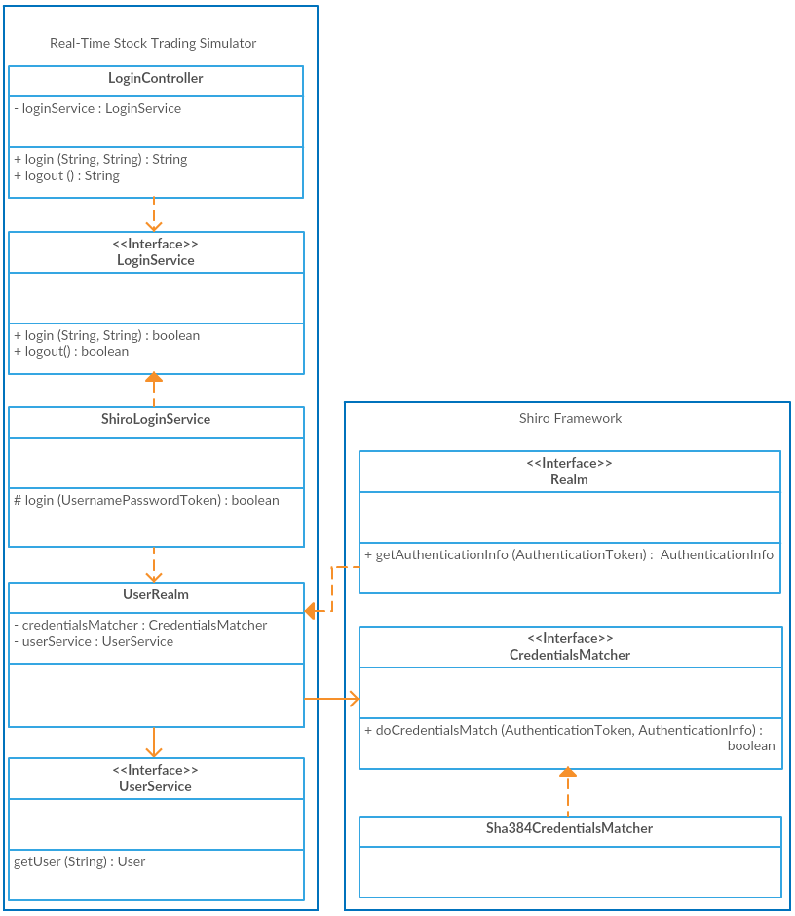
Figure 2 – Shiro security implementation as per Technical Design I
Both Shiro and Spring provide an easy way to do this, without having to annotate every @RequestMapping method requiring authentication or authorisation. Spring Security does this through its SecurityConfig (see Figure 1). Shiro takes a different approach with a configurable .ini file (see Figure 3).
[urls]
/css/** = anon
/index = anon
/account/** = authc, roles[user]
/stocks/** = authc, roles[user]
/reports/** = authc, roles[user]
/admin/** = authc, roles[admin]
Figure 3 – Shiro page authorisation config
File configuration has an advantage over code configuration as files can be easily modified. For instance, needing to change the permissions of a subpage such as ‘/reports/delete’ to an admin role would require repackaging and redeploying if using Spring’s SecurityConfig. Using file-based configuration such as in Shiro would mean only needing to change an external file, and optionally adding it to the top of the class path of the web application if necessary (for instance, if the application is using a pre-packaged configuration file). Furthermore, all configuration can be easily placed in a singular location, thus heightening maintainability.
Performance
In order to measure the performance of the given technologies and designs of Technical Design I and Technical Design II, basic proof of concept implementations were developed (Appendix 1, Appendix 2). The two security frameworks were integrated with a Spring Boot project with MySQL as the database system.
Four tests were written (Appendix 3) to measure the amount of time it takes to login with incorrect login data, as well as correct login data (using the same credentials for each successful login). No caching implementation was utilised for either framework
Test | Test Description | Spring Security | Shiro
testSuccessfulLoginAvgTime | Average time (ms) for a single successful login request | 4 | 9
testUnsuccessfulLoginAvgTime | Average time (ms) for a single unsuccessful login request | 4 | 10
testParallelSuccessfulLoginAvgTime | Average time (ms) for 100 parallel successful login requests | 562 | 559
testParallelUnsuccessfulLoginAvgTime | Average time (ms) for 100 parallel unsuccessful login requests | 678 | 1338
Table 5 – Security framework performance test results
Maintainability
We can also measure the maintainability of projects performing the bare minimum, using the designs from Technical Design I and Technical Design II, to login with either Spring Security or Shiro, with the given implementations (Appendix 1, Appendix 2).
Metric | Spring Security | Shiro
Coupling Between Objects (CBO) | 0 | 0 | 0 | 0
Depth of Inheritance Tree (DIT) | 5 | 1 | 5 | 1
Number Of Children (NOC) | 0 | 0 | 0 | 0
Response For Class (RFC) | 7 | 1.75 | 15 | 3
Weighted Methods for Class (WMC) | 6 | 1.5 | 8 | 1.6
Table 6 – Security framework bare minimum implementation metrics

Database Transactions
Data Access Design
Database transactions are covered by the security frameworks and handled in a black box by the security classes – each security framework has a default mechanism to retrieve username, password, and account status (disabled or enabled). However, a fleshed out design is required to handle database access required for the remaining services, e.g. UserService for user detail access, UserStockService to account for user-owned stocks, StockService for all accountable stocks, CompanyService, etc.
Technical Design I extends on the use of Spring JDBC, using the Spring Data JPA framework. A concrete Service class contains a JpaRepository interface, where the JpaRepository implementation is generated by Spring, where common methods are already implemented. If necessary, additional queries can be generated based on method names or @Query annotations.
package com.liemily.springdatajpaexample.stock;
import org.springframework.data.jpa.repository.JpaRepository;

public interface StockRepository extends JpaRepository<Stock, String> {
}
Figure 4 – JpaRepository example
package com.liemily.springdatajpaexample.stock;
package com.liemily.springdatajpaexample.stock;
import org.springframework.beans.factory.annotation.Autowired;
import org.springframework.stereotype.Service;
import org.springframework.transaction.annotation.Transactional;
import java.util.ArrayList;
import java.util.Iterator;
import java.util.List;

@Service
public class StockService {
private StockRepository stockRepository;

@Autowired
public StockService(StockRepository stockRepository) {
this.stockRepository = stockRepository;
}

@Transactional(readOnly = true)
public Stock findOne(String stockSymbol) {
return stockRepository.findOne(stockSymbol);
}

@Transactional(readOnly = true)
public List<Stock> findAll() {
List<Stock> stocks = new ArrayList<>();
Iterator<Stock> stockIterator = stockRepository.findAll().iterator();
stockIterator.forEachRemaining(stocks::add);
return stocks;
}

@Transactional
public Stock save(Stock stock) {
return stockRepository.save(stock);
}

@Transactional
public List<Stock> save(Iterable<Stock> stocks) {
return stockRepository.save(stocks);
}

@Transactional
public void delete(String stockSymbol) {
stockRepository.delete(stockSymbol);
}

@Transactional
public void delete(Iterable<Stock> stocks) {
stockRepository.delete(stocks);
}
}
Figure 5– StockService with JpaRepository example
Technical Design II instead implements its own DAL classes which are not object specific. For instance, the former design suggests a StockService using a StockRepository to retrieve stocks by a specific query. Instead, Technical Design II would expect all services, including a StockService, to use a DAL class specific to the way in which the database access is performed, e.g. HibernateDAL. Each service would then define its own query and call the DAL class accordingly.
package com.liemily.hibernateexample.stock;
import com.liemily.hibernateexample.dataaccess.HibernateDAL;
import org.springframework.beans.factory.annotation.Autowired;
import org.springframework.stereotype.Component;
import java.util.ArrayList;
import java.util.List;
import java.util.Set;

@Component
public class StockService {
private HibernateDAL hibernateDAL;

@Autowired
public StockService(HibernateDAL hibernateDAL) {
this.hibernateDAL = hibernateDAL;
}

public boolean save(Stock stock) throws InterruptedException {
hibernateDAL.save(stock);
return true;
}

public void save(Set<Stock> stocks) throws InterruptedException {
for (Stock stock : stocks) {
save(stock);
}
}

public Stock findOne(String stockSymbol) throws InterruptedException {
List<Stock> stock = hibernateDAL.query("FROM Stock WHERE symbol='" + stockSymbol + "'");
return stock.size() == 1 ? stock.get(0) : null;
}

public List<Stock> findAll() throws InterruptedException {
List<Stock> stock = hibernateDAL.query("FROM Stock");
return stock == null ? new ArrayList<>() : stock;
}

public void delete(String stockSymbol) throws InterruptedException {
hibernateDAL.delete("com.liemily.hibernateexample.stock.Stock", stockSymbol);
}

public void delete(Set<String> stockSymbols) throws InterruptedException {
final String DELIM = ", ";
StringBuilder query = new StringBuilder("DELETE FROM Stock WHERE symbol IN (");
stockSymbols.forEach(symbol -> query.append("'").append(symbol).append("'").append(DELIM));
query.setLength(query.length() - DELIM.length());
query.append(")");
hibernateDAL.execute(query.toString());
}
}
Figure 6 – HibernateDAL example
@Component
public class StockService {
private HibernateDAL hibernateDAL;

@Autowired
public StockService(HibernateDAL hibernateDAL) {
this.hibernateDAL = hibernateDAL;
}

public boolean save(Stock stock) throws InterruptedException {
hibernateDAL.save(stock);
return true;
}

public void save(Set<Stock> stocks) throws InterruptedException {
for (Stock stock : stocks) {
save(stock);
}
}

public Stock findOne(String stockSymbol) throws InterruptedException {
List<Stock> stock = hibernateDAL.query("FROM Stock WHERE symbol='" + stockSymbol + "'");
return stock.size() == 1 ? stock.get(0) : null;
}

public List<Stock> findAll() throws InterruptedException {
List<Stock> stock = hibernateDAL.query("FROM Stock");
return stock == null ? new ArrayList<>() : stock;
}

public void delete(String stockSymbol) throws InterruptedException {
hibernateDAL.delete("com.liemily.hibernateexample.stock.Stock", stockSymbol);
}

public void delete(Set<String> stockSymbols) throws InterruptedException {
final String DELIM = ", ";
StringBuilder query = new StringBuilder("DELETE FROM Stock WHERE symbol IN (");
stockSymbols.forEach(symbol -> query.append("'").append(symbol).append("'").append(DELIM));
query.setLength(query.length() - DELIM.length());
query.append(")");
hibernateDAL.execute(query.toString());
}
}
Figure 7 – StockService with HibernateDAL example
The design avoiding Spring Data emphasises the boilerplate that is covered by using a JpaRepository. There are instances of SQL in both the HibernateDAL and StockService classes which make the design more vulnerable to database system changes, thus affecting both maintainability and reliability. On the contrary, there is no SQL present at all when using Spring Data and performing simple CRUD activity.
Performance
In order to measure the performance of the above designs, two proof of concepts were implemented (Appendix 4, Appendix 5) using Spring Boot and the same MySQL database and schema.
CREATE TABLE IF NOT EXISTS `stock` (
`symbol` VARCHAR(50) NOT NULL PRIMARY KEY,
`value` DECIMAL(13,2) NOT NULL,
`volume` INT NOT NULL
);
Figure 8 – Stock table definition
The Hibernate connection pool was made to be the same as the default set by Spring Data. The tests (Appendix 6) covered both read and write activity. Read activity was tested with a single thread and in parallel. Write activity was only tested with a single thread. This is because write activity locks a table so multi-threaded testing was moot. Tests in parallel ran with 100 threads and a connection pool of 100 connections.
Test | Test Description | Spring Data | Hibernate
testFindStockAvgTime | Average time (ms) querying for a single stock | 1 | 2
testParallelFindStockAvgTime | Average time (ms) querying for the same single stock in parallel | 4 | 110
testFindAllStocksAvgTime | Average time (ms) querying for 1000 written results | 4 | 1
testParallelFindAllStocksAvgTime | Average time (ms) querying for 1000 written results in parallel | 480 | 13
testWriteSingleStockAvgTime | Average time (ms) writing a single row | 3 | 2
testWriteMultipleStocksAvgTime | Average time (ms) writing 1000 unique rows in batches of 100 | 6 | 11
Table 7 – Database access performance test results
The performance test results show two anomalies which are unexplained. For one, Spring Data's database implementation appears to be more efficient than the implementation using Hibernate when querying for a specific stock. Secondly, Spring Data's implementation is worse than the implementation using Hibernate when querying for all existing stocks.
Maintainability
The Chidamber-Kimerer metrics of the projects in Appendices 1 and 2 were measured, as shown in Table 8. These should be considered keeping in mind the heavy reliance on Spring Data and Hibernate in either project. More code is exposed in the Hibernate implementation, and the complexities of both Spring Data and Hibernate are included in the given metrics. Additionally, comparison should also include the metrics of Table 4 which covers the Spring Data JdbcTemplate and Hibernate SessionImpl.
Metric  (Total | Average) | Spring Data | Hibernate
Coupling Between Objects (CBO) | 6 | 2 | 8 | 1.6
Depth of Inheritance Tree (DIT) | 3 | 1 | 5 | 1
Number Of Children (NOC) | 0 | 0 | 0 | 0
Response For Class (RFC) | 28 | 7 | 67 | 9.6
Weighted Methods for Class (WMC) | 21 | 7 | 39 | 7.8
Table 8 – Simple database access implementation metrics

Trades
The two technical designs employ trading in the simulation using Broker classes (Appendix 7, Appendix 8). The Broker class utilises Service classes which provide access to the underlying database in order to perform the trades.
The designs differ in their consideration of the Broker.
- Technical Design I decouples the broker from the MVC flow
  - This is demonstrated by the OrderController and OrderService which direct Order's to the Broker
  - The Broker uses Service's to enact the trade and informs the OrderService of the trade
  - The OrderService persists the order history
- Technical Design II considers the Broker an essential class
  - A BrokerController sends trade requests directly to the Broker
  - The Broker uses the TradeService to persist trade history
In order to measure the designs in a concrete way, the two designs were implemented to the extent that a trade could be submitted to the broker for verification and processing, and finally persisted (Appendix 9, Appendix 10). (There is some variance in class and method names in the implementations compared to the designs.) As much as possible was kept the same in the two designs, such as the database access method, to reduce confounding metrics. Performance was not tested as the different designs were not thought to give much variance in this regard.
Metric  (Total | Average) | Technical Design I  (via OrderController) | Technical Design II  (via BrokerController)
Coupling Between Objects (CBO) | 64 | 4.12 | 73 | 4.29
Depth of Inheritance Tree (DIT) | 23 | 1.53 | 24 | 1.5
Number Of Children (NOC) | 0 | 0 | 0 | 0
Response For Class (RFC) | 136 | 6.8 | 164 | 7.81
Weighted Methods for Class (WMC) | 104 | 6.5 | 110 | 6.47
Table 9 – Broker implementation metrics

Reports
Report generation in Technical Design I and Technical Design II have significant differences. The class diagrammes are available at Appendices 11 and 12. In short, the activity of the first design is as follows:
- Provides a ReportRequest from the ReportController to the ReportService
- The ReportService calls the ReportInitialiser to initialise a Spring POJO of the report
- The ReportService calls the Report to execute
- The report calls the required services, e.g. StockService, UserService, etc. to extract the required information
- The report transforms this into CSV or XML format according to the ReportRequest
- This output is then returned to the ReportService to return to the ReportController
The second design:
- Provides a ReportRequest from the ReportController to the ReportGenerator
- The ReportGenerator calls the required services, e.g. StockService, UserService, etc. to retrieve the required information
- The ReportGenerator populates the report with this information
- The ReportGenerator transforms this to CSV or XML according to the ReportRequest
- The ReportGenerator returns this to the ReportController
The main difference is that the first design contains Report classes that contain business logic. The Report classes call services to access the database. The second design instead treats a report as purely a definition and contains the business logic in the ReportGenerator.
public abstract class Report {
private static final Logger logger = LogManager.getLogger(MethodHandles.lookup().lookupClass());

private ReportWriter reportWriter;

public Report(ReportWriter reportWriter) {
this.reportWriter = reportWriter;
}

abstract ReportItems generateReportItems(ReportRequest reportRequest);

public Path executeReport(ReportRequest reportRequest) throws ReportGenerationException {
ReportItems reportItems = generateReportItems(reportRequest);
Path reportPath = generateReportPath(reportRequest.getFileType());
reportWriter.write(reportItems, reportRequest.getFileType(), reportPath);
return reportPath;
}

private Path generateReportPath(FILE_TYPE fileType) {
Path path = Paths.get(UUID.randomUUID().toString() + "." + fileType.toString().toLowerCase());
path.toFile().deleteOnExit();
return path;
}
}
@Component
@Lazy
public class StockReport extends Report {
private StockService stockService;

@Autowired
public StockReport(ReportWriter reportWriter, StockService stockService) {
super(reportWriter);
this.stockService = stockService;
}

@Override
ReportItems generateReportItems(ReportRequest reportRequest) {
Collection<ReportItem> reportItems = new ArrayList<>();
Sort.Direction sortDirection = reportRequest.getSortDirection() == null ? Sort.DEFAULT_DIRECTION : reportRequest.getSortDirection();
Collection<Stock> stocks = getStocks(sortDirection);
for (Stock stock : stocks) {
ReportItem reportItem = new ReportItem(stock.getSymbol(), stock.getSymbol(), stock.getValue(), stock.getVolume(), new BigDecimal("0"));
reportItems.add(reportItem);
}
return new ReportItems(reportItems);
}

private Collection<Stock> getStocks(Sort.Direction direction) {
Sort sort = new Sort(direction, "value");
return stockService.getStocks(sort);
}
}
Figure 9 – Report execution logic of Technical Design I's Report and StockReport classes
@Component
@Lazy
public class ReportGenerator {
private static final Logger logger = LogManager.getLogger(MethodHandles.lookup().lookupClass());

private StockService stockService;
private ReportWriter reportWriter;

@Autowired
public ReportGenerator(StockService stockService, ReportWriter reportWriter) {
this.stockService = stockService;
this.reportWriter = reportWriter;
}

public Report generate(ReportRequest reportRequest) throws ReportGenerationException {
ReportItems reportItems = generateReportItems(reportRequest);
Path reportPath = generateReportPath(reportRequest.getFileType());
reportWriter.write(reportItems, reportRequest.getFileType(), reportPath);
return new Report(reportPath, reportRequest);
}

private ReportItems generateReportItems(ReportRequest reportRequest) {
List<ReportItem> reportItems = new ArrayList<>();
List<Stock> stocks = new ArrayList<>();
if (reportRequest.getReportName().equals(REPORT_NAME.STOCK_REPORT)) {
stocks = getStocks(reportRequest.getSortDirection());
}
stocks.forEach(stock -> reportItems.add(new ReportItem(stock.getSymbol(), stock.getSymbol(), stock.getValue(), stock.getVolume(), new BigDecimal(0))));
return new ReportItems(reportItems);
}

private List<Stock> getStocks(Sort.Direction sortDirection) {
Sort sort = new Sort(sortDirection, "value");
return stockService.getStocks(sort);
}

private Path generateReportPath(FILE_TYPE fileType) {
Path path = Paths.get(UUID.randomUUID().toString() + "." + fileType.toString().toLowerCase());
path.toFile().deleteOnExit();
return path;
}
}
Figure 10 – Report execution logic of Technical Design II's ReportGenerator class
To measure the benefits of the designs, two basic implementations were developed in order to calculate the according metrics. The implementations were developed to the extent that a basic stock report could be populated and written to XML (Appendix 13, Appendix 14).
Metric  (Total | Average) | Technical Design I  (via ReportService) | Technical Design II  (via ReportGenerator)
Coupling Between Objects (CBO) | 70 | 5 | 49 | 4.08
Depth of Inheritance Tree (DIT) | 21 | 1.75 | 18 | 1.8
Number Of Children (NOC) | 3 | 0.25 | 2 | 1.17
Response For Class (RFC) | 101 | 7.21 | 92 | 7.67
Weighted Methods for Class (WMC) | 38 | 2.71 | 35 | 2.92
Table 10 – Report generation design metrics on ReportGeneration module

Stock Value Generator
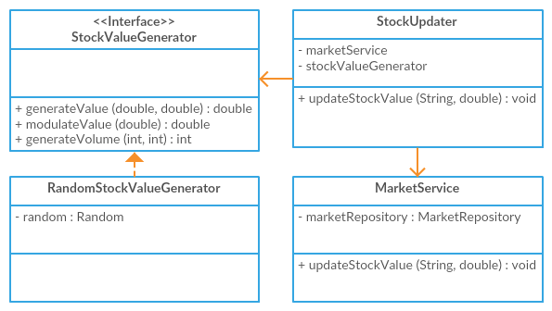
Figure 11 – StockValueGenerator class diagramme from Technical Design I document
The design of the stock value generator relies on the way in which database access are designed. The design proposed in Technical Design I decouples the database access layer from the StockValueGenerator. The design of Technical Design II expects a concrete StockGenerationService to be implemented which queries the database with a member object.
Metric  (Total | Average) | Technical Design I  (via StockUpdater) | Technical Design II  (via StockGenerationService)
Coupling Between Objects (CBO) | 10 | 2 | 10 | 2
Depth of Inheritance Tree (DIT) | 5 | 1 | 7 | 1.4
Number Of Children (NOC) | 0 | 0 | 0 | 0
Response For Class (RFC) | 45 | 7.5 | 33 | 5.5
Weighted Methods for Class (WMC) | 17 | 3.4 | 13 | 2.6
Table 11 – Stock value generation Chidamber-Kemerer metrics from example implementations (Appendix 15, Appendix 16)
The design shown in Figure 11 shows the use of a concrete StockUpdater utilising dependency inversion for its StockValueGenerator. The StockValueGenerator is an interface to attempt to allow for any possible implementation for stock value generation. For instance, this is implemented in the above with a RandomStockValueGenerator that simply uses a Random object to allow the StockValueGenerator to modulate values. An alternative might be a SecureRandomStockValueGenerator.
In contrast, the main class in question in Figure 12 is the StockGenerationService, which itself is an interface. This interface is implemented by a concrete class that uses a StockGenerator but could hypothetically perform stock generation within itself. The concrete class also represents the way in which the stocks are read and written to the database – through MySQL.
The StockUpdater of the first design instead has a hold on the concrete MarketService for database access. The MarketService encapsulates the way in which the stocks are read and written and this is thus separated from the Stock module. The designs are heavily linked to the separate design choices for database access and performance of the different designs are thus expected to be correlated with the metrics given in Table 7.
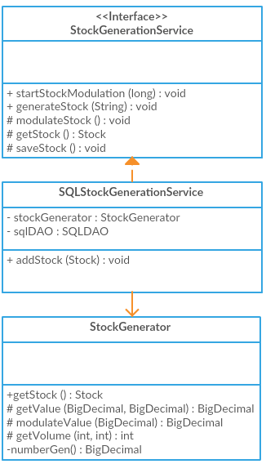
Figure 12 – StockValueService class diagramme from Technical Design II document

Appendices
- spring-security-example
- shiro-example
- Security framework performance tests
- spring-data-jpa-example
- hibernate-example
- Database access performance tests
- Technical Design I Broker class diagramme
- Technical Design II Broker class diagramme
- order-service-broker-example
- broker-orchestrator-example
- Technical Design I ReportService class diagramme
- Technical Design II ReportGenerator class diagramme
- report-service-example
- report-generator-example
- stock-updater-example
- stock-generation-service-example

Appendix 1
https://github.com/emily-li/spring-security-example
Appendix 2
https://github.com/emily-li/shiro-example
Appendix 3
package com.liemily.web;
import org.apache.log4j.LogManager;
import org.apache.log4j.Logger;
import org.junit.Before;
import org.junit.Test;
import org.junit.runner.RunWith;
import org.springframework.beans.factory.annotation.Autowired;
import org.springframework.beans.factory.annotation.Value;
import org.springframework.boot.context.embedded.LocalServerPort;
import org.springframework.boot.test.context.SpringBootTest;
import org.springframework.boot.test.web.client.TestRestTemplate;
import org.springframework.http.HttpEntity;
import org.springframework.http.HttpHeaders;
import org.springframework.http.MediaType;
import org.springframework.http.ResponseEntity;
import org.springframework.test.context.junit4.SpringRunner;
import org.springframework.util.LinkedMultiValueMap;
import org.springframework.util.MultiValueMap;
import java.util.ArrayList;
import java.util.Collection;
import java.util.List;
import java.util.concurrent.Callable;
import java.util.concurrent.ExecutorService;
import java.util.concurrent.Executors;
import java.util.concurrent.Future;
import java.util.stream.IntStream;
import static org.assertj.core.api.Assertions.assertThat;

/**
* Created by Emily Li on 17/07/2017.
*/
@RunWith(SpringRunner.class)
@SpringBootTest(webEnvironment = SpringBootTest.WebEnvironment.RANDOM_PORT)
public class WebApplicationTest {
private static final Logger logger = LogManager.getLogger(WebApplicationTest.class);
@LocalServerPort
private int port;
@Autowired
private TestRestTemplate restTemplate;
@Value("${spring.boot.test.user}")
private String user;
@Value("${spring.boot.test.password}")
private String password;
private String url;
private final int AVG_RUN_COUNT = 100;
private final long MAX_REQUEST_WAIT_MS = 1000;

@Before
public void setup() {
url = "http://localhost:" + port;
restTemplate.getForObject(url, String.class); // First server request initialises server components which takes longer, so run this before performance checks
}

@Test
public void testSuccessfulLogin() throws Exception {
ResponseEntity<String> response = postForLogin(user, password);
assertThat(response.getHeaders().get("Location").get(0)).isEqualTo(url + "/");
}

@Test
public void testUnsuccessfulLogin() throws Exception {
ResponseEntity<String> response = postForLogin(user, null);
assertThat(response.getHeaders().get("Location").get(0)).isEqualTo(url + "/login?error");
}

@Test
public void testSuccessfulLoginAvgTime() throws Exception {
long time = timeParallelPostForLogin(user, password, AVG_RUN_COUNT, 1);
assertThat(time).isLessThan(MAX_REQUEST_WAIT_MS);
}

@Test
public void testUnsuccessfulLoginAvgTime() throws Exception {
long time = timeParallelPostForLogin(user, "", AVG_RUN_COUNT, 1);
assertThat(time).isLessThan(MAX_REQUEST_WAIT_MS);
}

@Test
public void testParallelSuccessfulLoginAvgTime() throws Exception {
long time = timeParallelPostForLogin(user, password, AVG_RUN_COUNT, AVG_RUN_COUNT);
assertThat(time).isLessThan(MAX_REQUEST_WAIT_MS);
}

@Test
public void testParallelUnsuccessfulLoginAvgTime() throws Exception {
long time = timeParallelPostForLogin(user, "", AVG_RUN_COUNT, AVG_RUN_COUNT);
assertThat(time).isLessThan(MAX_REQUEST_WAIT_MS);
}

private ResponseEntity<String> postForLogin(String user, String password) {
HttpHeaders headers = new HttpHeaders();
headers.setContentType(MediaType.APPLICATION_FORM_URLENCODED);
MultiValueMap<String, String> map = new LinkedMultiValueMap<String, String>();
map.add("username", user);
map.add("password", password);
HttpEntity<MultiValueMap<String, String>> request = new HttpEntity<MultiValueMap<String, String>>(map, headers);
return restTemplate.postForEntity(url + "/login", request, String.class);
}
private long timePostForLogin(String user, String password) {
long startTime = System.currentTimeMillis();
postForLogin(user, password);
long stopTime = System.currentTimeMillis();
return stopTime - startTime;
}
private long timeParallelPostForLogin(String user, String password, int numTasks, int parallelThreads) throws Exception {
ExecutorService executorService = Executors.newFixedThreadPool(parallelThreads);
Collection<LoginTask> loginTasks = new ArrayList<>();
IntStream.range(0, numTasks).forEach(i -> loginTasks.add(new LoginTask(user, password)));
long invokeStart = System.currentTimeMillis();
List<Future<Long>> times = executorService.invokeAll(loginTasks);
long avg = 0;
for (Future<Long> time : times) {
avg += time.get();
}
long invokeStop = System.currentTimeMillis();
avg /= AVG_RUN_COUNT;
logger.info("Average run time of login tasks was " + avg + "ms");
logger.info("All " + numTasks + " login tasks ran in " + (invokeStop - invokeStart) + "ms");
return avg;
}
private class LoginTask implements Callable<Long> {
private String user;
private String password;
LoginTask(String user, String password) {
this.user = user;
this.password = password;
}
@Override
public Long call() throws Exception {
return timePostForLogin(user, password);
}
}
}

Appendix 4
https://github.com/emily-li/spring-data-jpa-example
Appendix 5
https://github.com/emily-li/hibernate-example
Appendix 6
package com.liemily.springdatajpaexample.stock;
import org.apache.log4j.LogManager;
import org.apache.log4j.Logger;
import org.junit.After;
import org.junit.Assert;
import org.junit.Before;
import org.junit.Test;
import org.junit.runner.RunWith;
import org.springframework.beans.factory.annotation.Autowired;
import org.springframework.boot.test.context.SpringBootTest;
import org.springframework.dao.EmptyResultDataAccessException;
import org.springframework.test.context.junit4.SpringRunner;
import java.math.BigDecimal;
import java.util.ArrayList;
import java.util.Collection;
import java.util.List;
import java.util.UUID;
import java.util.concurrent.Callable;
import java.util.concurrent.ExecutorService;
import java.util.concurrent.Executors;
import java.util.concurrent.Future;
import java.util.stream.IntStream;

@RunWith(SpringRunner.class)
@SpringBootTest
public class StockServiceTest {
private static final Logger logger = LogManager.getLogger(StockServiceTest.class);
private final int AVG_RUN_COUNT = 1000;
private final int BATCH_COUNT = 100;
@Autowired
private StockService stockService;
private String stockSymbol;

@Before
public void setup() {
stockSymbol = "SYM" + UUID.randomUUID();
}

@After
public void tearDown() {
try {
stockService.delete(stockSymbol);
} catch (EmptyResultDataAccessException e) {
logger.info("Attempted to delete stock " + stockSymbol + " but it was not present in the database");
}
}

@Test
public void testWriteStock() {
Stock stock = new Stock(stockSymbol, new BigDecimal(1.5), 1);
stockService.save(stock);
Stock foundStock = stockService.findOne(stockSymbol);
Assert.assertEquals(stock, foundStock);
}

@Test
public void testDeleteStock() {
Stock stock = new Stock(stockSymbol, new BigDecimal(1.5), 1);
stockService.save(stock);
Stock foundStock = stockService.findOne(stockSymbol);
Assert.assertEquals(stock, foundStock);
stockService.delete(stockSymbol);
Stock deletedStock = stockService.findOne(stockSymbol);
Assert.assertNull(deletedStock);
}

@Test
public void testWriteSingleStockAvgTime() {
List<Stock> stocks = generateStocks(AVG_RUN_COUNT);
try {
long totalTimeMs = timeWriteStocks(stocks, 1);
logger.info("Average run time for writing a single stock was " + (totalTimeMs / AVG_RUN_COUNT) + "ms");
logger.info("Total time taken to write " + AVG_RUN_COUNT + " stocks was " + totalTimeMs);
} finally {
stockService.delete(stocks);
}
}

@Test
public void testWriteMultipleStocksAvgTime() {
List<Stock> stocks = generateStocks(AVG_RUN_COUNT);
try {
long totalTimeMs = timeWriteStocks(stocks, BATCH_COUNT);
logger.info("Average run time for writing a stock batch of " + BATCH_COUNT + " was " + (totalTimeMs / BATCH_COUNT) + "ms");
logger.info("Total time taken to write " + AVG_RUN_COUNT + " stocks was " + totalTimeMs);
} finally {
stockService.delete(stocks);
}
}

@Test
public void testFindStockAvgTime() {
Stock stock = new Stock(stockSymbol, new BigDecimal(1.5), 1);
stockService.save(stock);
long totalTimeMs = 0;
for (int i = 0; i < AVG_RUN_COUNT; i++) {
totalTimeMs += timeFindStock(stockSymbol);
}
logger.info("Average run time to find a stock was " + (totalTimeMs / AVG_RUN_COUNT) + "ms");
logger.info("Total time taken to find a stock with " + AVG_RUN_COUNT + " individual requests was " + totalTimeMs);
}

@Test
public void testParallelFindStockAvgTime() throws Exception {
Stock stock = new Stock(stockSymbol, new BigDecimal(1.5), 1);
stockService.save(stock);
ExecutorService executorService = Executors.newFixedThreadPool(AVG_RUN_COUNT);
Collection<FindOneTask> findTasks = new ArrayList<>();
IntStream.range(0, AVG_RUN_COUNT).forEach(i -> findTasks.add(new FindOneTask(stockSymbol)));
List<Future<Long>> times = executorService.invokeAll(findTasks);
long totalTimeMs = 0;
for (Future<Long> time : times) {
totalTimeMs += time.get();
}
logger.info("Average run time to find a stock was " + (totalTimeMs / AVG_RUN_COUNT) + "ms");
logger.info("Total time taken to find a stock with " + AVG_RUN_COUNT + " individual requests was " + totalTimeMs);
}

@Test
public void testFindAllStocksAvgTime() {
Collection<Stock> stocks = generateStocks(AVG_RUN_COUNT);
try {
stockService.save(stocks);
long totalTimeMs = 0;
for (int i = 0; i < AVG_RUN_COUNT; i++) {
totalTimeMs += timeFindStocks();
}
logger.info("Average run time to find all stocks was " + (totalTimeMs / AVG_RUN_COUNT) + "ms");
logger.info("Total time taken to find all stocks with " + AVG_RUN_COUNT + " individual requests was " + totalTimeMs);
} finally {
stockService.delete(stocks);
}
}

@Test
public void testParallelFindAllStocksAvgTime() throws Exception {
Collection<Stock> stocks = generateStocks(AVG_RUN_COUNT);
try {
stockService.save(stocks);
ExecutorService executorService = Executors.newFixedThreadPool(AVG_RUN_COUNT);
Collection<FindAllTask> findTasks = new ArrayList<>();
IntStream.range(0, AVG_RUN_COUNT).forEach(i -> findTasks.add(new FindAllTask()));
List<Future<Long>> times = executorService.invokeAll(findTasks);
long totalTimeMs = 0;
for (Future<Long> time : times) {
totalTimeMs += time.get();
}
logger.info("Average run time to find all stocks was " + (totalTimeMs / AVG_RUN_COUNT) + "ms");
logger.info("Total time taken to find all stocks with " + AVG_RUN_COUNT + " individual requests was " + totalTimeMs);
} finally {
stockService.delete(stocks);
}
}

List<Stock> generateStocks(int numStocks) {
List<Stock> stocks = new ArrayList<>();
String id = UUID.randomUUID().toString();
IntStream.range(0, numStocks).forEach(i -> stocks.add(new Stock(id + i, new BigDecimal(1.5), 1)));
return stocks;
}

private long timeWriteStocks(List<Stock> stocks, int batchCount) {
long totalTimeMs = 0;
long startTime = System.currentTimeMillis();
for (int i = 0; i < stocks.size(); i += batchCount) {
stockService.save(stocks.subList(i, i + batchCount));
long endTime = System.currentTimeMillis();
totalTimeMs += endTime - startTime;
startTime = endTime;
}
return totalTimeMs;
}

private long timeFindStock(String stockSymbol) {
long startTimeMs = System.currentTimeMillis();
stockService.findOne(stockSymbol);
long endTimeMs = System.currentTimeMillis();
return endTimeMs - startTimeMs;
}

private long timeFindStocks() {
long startTimeMs = System.currentTimeMillis();
stockService.findAll();
long endTimeMs = System.currentTimeMillis();
return endTimeMs - startTimeMs;
}

private class FindOneTask implements Callable<Long> {
private String id;
private FindOneTask(String id) {
this.id = id;
}
@Override
public Long call() throws Exception {
return timeFindStock(id);
}
}

private class FindAllTask implements Callable<Long> {
@Override
public Long call() throws Exception {
return timeFindStocks();
}
}
}

Appendix 7
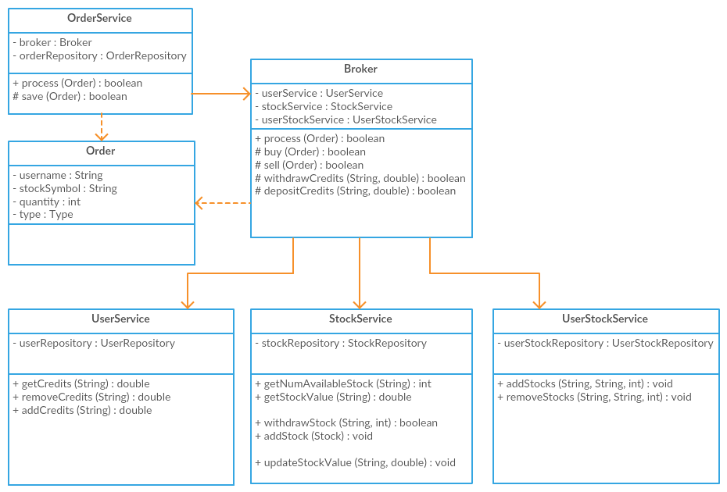

Appendix 8
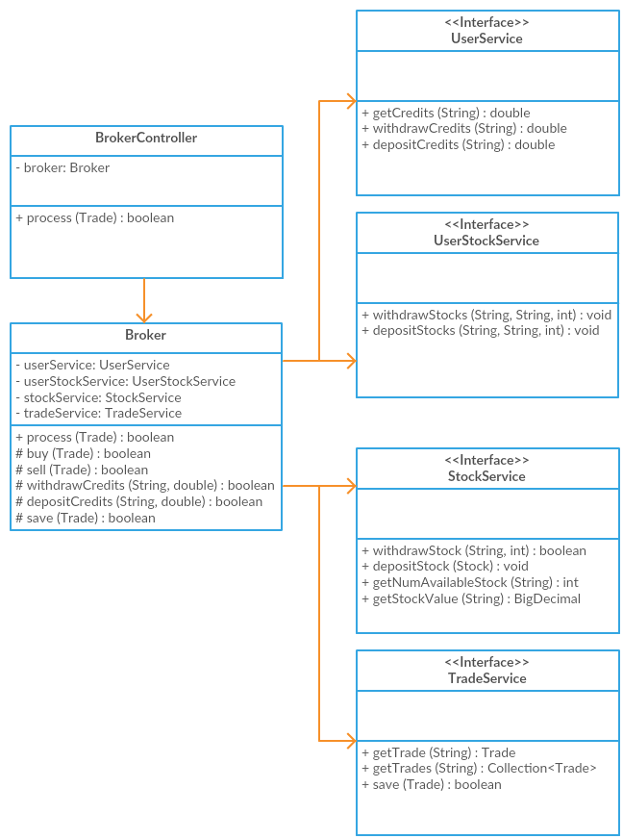
Appendix 9
https://github.com/emily-li/order-service-broker-example
Appendix 10
https://github.com/emily-li/broker-orchestrator-example

Appendix 11
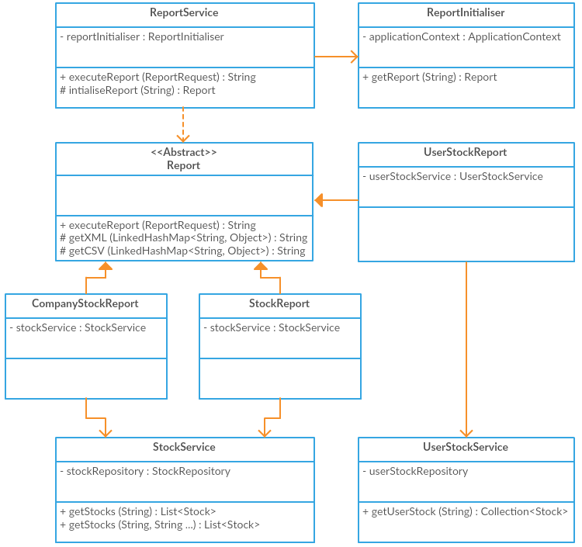

Appendix 12
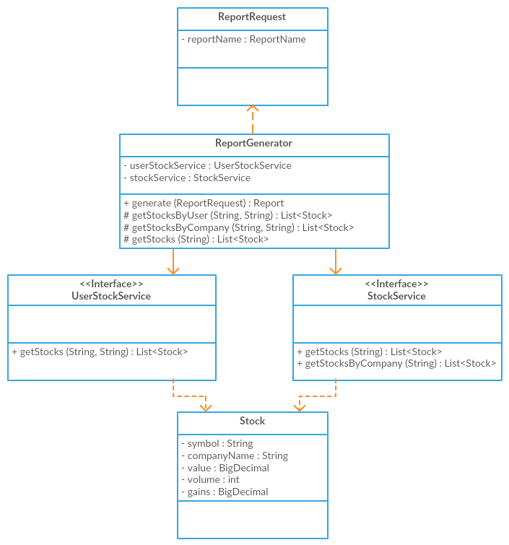

Appendix 13
https://github.com/emily-li/report-service-example
Appendix 14
https://github.com/emily-li/report-generator-example
Appendix 15
https://github.com/emily-li/stock-updater-example
Appendix 16
https://github.com/emily-li/stock-generation-service-example
References
Apache (2016) 2.3.26 (incubating at Apache) [online] http://freemarker.org/docs/versions_2_3_26.html (Accessed 20 June 2017)
Khan (2017) Templating Engines for Java WebApps [online], https://javaeworld.blogspot.co.uk/2017/02/template-engines-for-java-webapps-velocity-freemarker-thymeleaf-rythm.html (Accessed 20 June 2017)
Leijdekkers, Bas (2016) MetricsReloaded [online] https://github.com/BasLeijdekkers/MetricsReloaded (Accessed 16 July 2017)
SonarQube (2017) Security-related rules [online] https://docs.sonarqube.org/display/SONAR/Security-related+rules (Accessed 10 July 2017)
Bibliography
Hibernate (2017) Hibernate – GitHub [online] https://github.com/hibernate (Accessed 26 June)
Hibernate (2017) Hibernate JavaDoc [online] https://docs.jboss.org/hibernate/orm/5.2/javadocs (Accessed 26 June)
Shiro (2017) Overview (Apache Shiro 1.3.2 API) [online] https://shiro.apache.org/static/1.3.2/apidocs (Accessed 22 June 2017)
Shiro (2017) shiro-root Source Repository [online] https://shiro.apache.org/static/1.3.2/source-repository.html (Accessed 22 June 2017)
Spring (2017) Spring [online] https://github.com/spring-projects (Accessed 22 June 2017)
Spring (2017) Spring Security 4.2.3.RELEASE API [online] http://docs.spring.io/spring-security/site/docs/4.2.3.RELEASE/apidocs (Accessed 22 June 2017)
Thymeleaf (2017) Documentation – Thymeleaf [online] http://www.thymeleaf.org/documentation.html (Accessed 10 July 2017)

